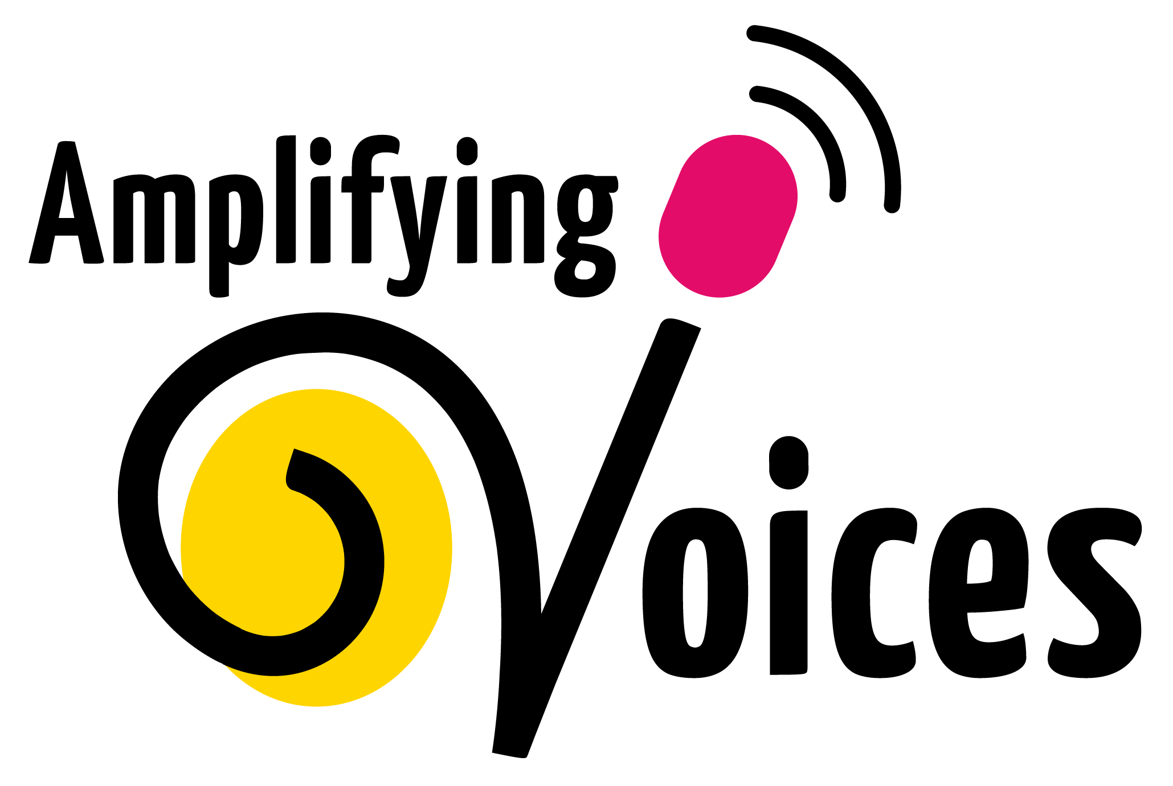
Category | What Congregation/ Community concerns did we hear? | What is our role in responding (signposting/engaging/informing?)
Information about COVID19 | Click or tap here to enter text. | Click or tap here to enter text.
Health – physical, hygiene | Click or tap here to enter text. | Click or tap here to enter text.
Health – mental, emotional | Click or tap here to enter text. | Click or tap here to enter text.
Food, nutrition and household items | Click or tap here to enter text. | Click or tap here to enter text.
Finances | Click or tap here to enter text. | Click or tap here to enter text.
Safe-guarding | Click or tap here to enter text. | Click or tap here to enter text.
Education | Click or tap here to enter text. | Click or tap here to enter text.
Spiritual | Click or tap here to enter text. | Click or tap here to enter text.

